**EXECUTIVE SUMMARY**

Coronavirus disease (COVID-19) is an infectious disease that affected major parts of the world. This Analysis project was aim at generating insight into the impact of Coronavirus disease (Covid 19)

in all the 37 states (Federal Capital territory included) in Nigeria.

The Dataset used were source as follows:

Nigeria Centre for Diseases Control (NCDC) official website.

Repository of Johns Hopkins University Center for Systems Science and Engineering (JHU CSSE).

Real Domestic Gross Product (GDP) data for Nigeria.

States Budget data.

**Project step:**

Dataset was scrap from NCDC official site, also dataset of Nigeria daily confirmed covid cases (lab test),

the daily recovered cases and daily death cases were extracted from the global daily cases on (JHU CSSE)

repository. The Real Domestic Gross Product (GDP) data for Nigeria was access as well.

These datasets were collated, clean, converted to the appropriate data types, filtered, merged were necessary, then transformed and visualized using Seaborn, matplotlib and pandas Python method.

**Insight**

Below where the insights generate from the analysis:

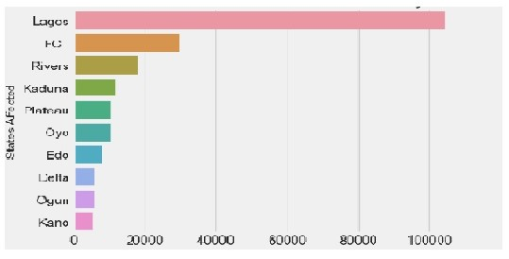

1- Lagos has the highest figure in term of covid confirmed cases (lab test), discharge cases and death cases. Follow by the Federal capital territory.

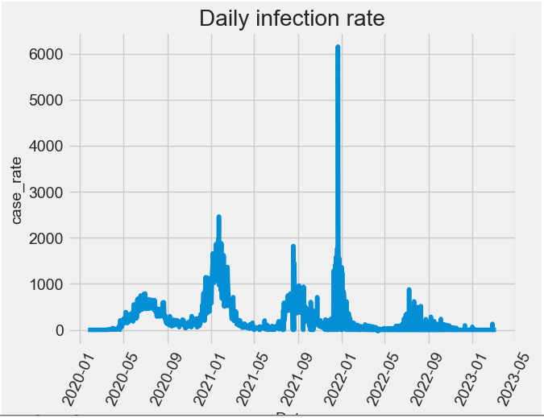

2-The maximum daily infection rate was 6155 and date for the maximum infection rate was 2021-12-22.

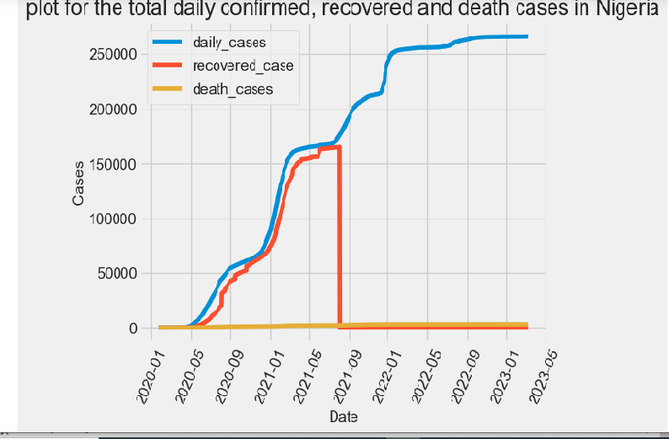

3- The daily confirmed cases keeping rising consistently, the daily recovering cases start rising initial but at a point it dropped abruptly. The daily death cases were not pronounced

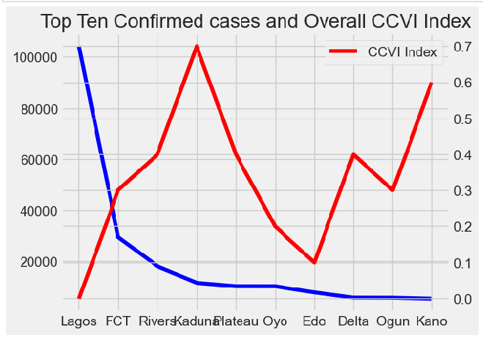

4-There is no positive correlation between confirmed cases and the overall Nigeria community vulnerability index. In Lagos state for instance where the confirmed cases are highest, it has a lowest CCVI index. (These could be attributed to access to information, health facilities performance e.t.c). Unlike Kaduna state where the confirmed cases are low but recorded the highest CCVI index.

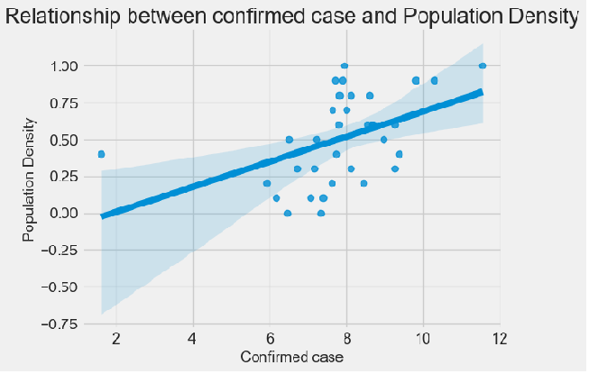

5- There is a linear relationship between the population density and the confirmed cases. The higher the population density, the more the number of confirmed cases.

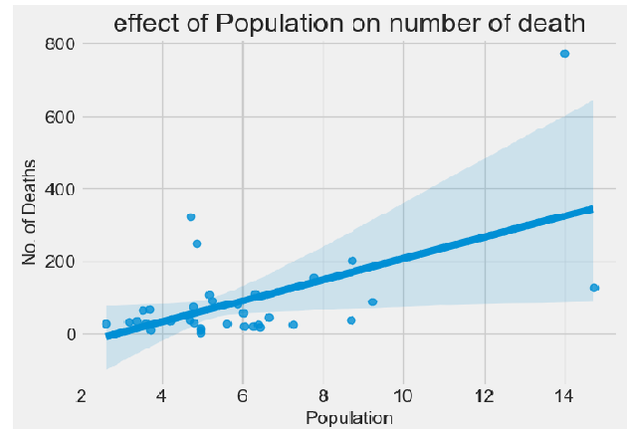

6- There is correlation between the population and death cases. The death cases were higher where the population is higher. However, there are few outliers.

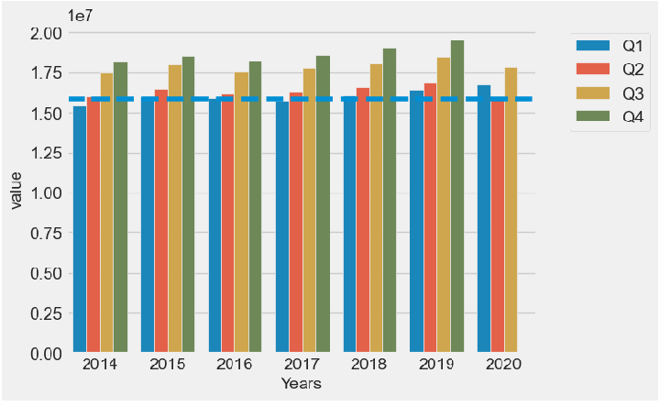

7-The value of GDP contracted in the second quarter of 2020 during the covid 19. These was a result of Impact of disease on the economy (the closure of major businesses, and curfew).

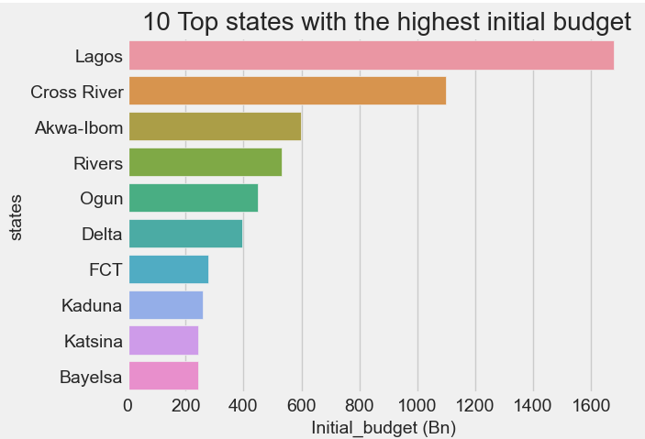

8-Lagos states have the highest initial budget follow by cross river states.

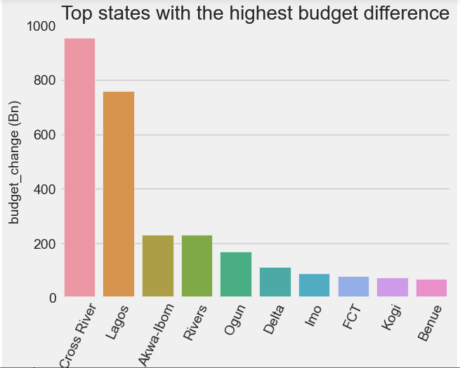

9-The impact of covid-19 forces states to revised their initial budget downward. Cross river had the highest budget difference, follow by Lagos state.

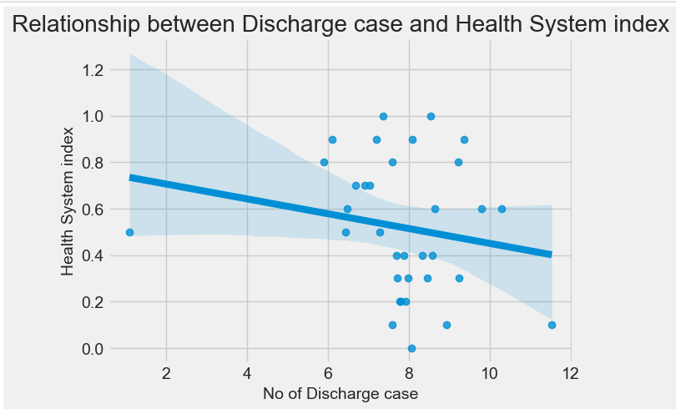

10- There is increase in number of discharge cases where there the heath system index is low. Implies the number of discharge cases is more where there is access to health care system.

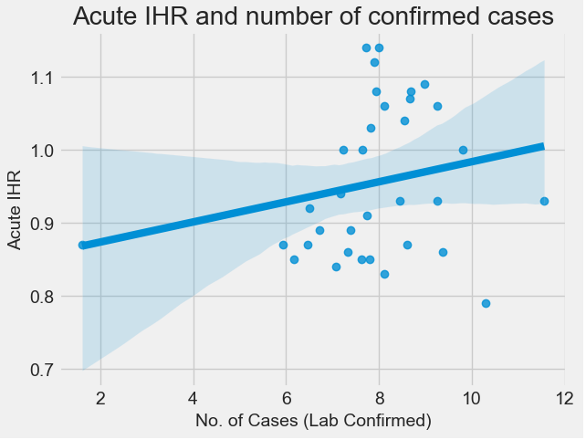

11- This is a relationship between Acute IHR index and the number of confirmed cases. The number of infected persons that need acute care increases slightly as the confirmed cases increases.

**Conclusion**, it is obvious that the coronavirus disease hit the economy hard impact and affected the countries activities. Which

Lead to shutting down businesses’ airports, state-wide lockdown and curfew.

**Recommendation**

They should be a deliberate stand by comprehensive Government policy that can mitigate against any

unforeseen circumstances.